Assumptions

General
- We can model human behaviour with empathetic Reinforcement Learning
  - Selfish or selfless behaviour
  - I don’t think we can model irrational human behaviours (e.g. crazy person)
- When behaving among “rational” human either selfish or selfless, a robot with E RL running can behave with humans like humans
- Robots programmed by different manufacturers
  - If these robots behave in a human-like manner enough, the ERL robot may be able to interact with them as it interact with a human being
  - For a range of behaviour patterns the ERL algorithm will be able to assign a empathy level and then take decisions on that value
- When there are 2 agents, e.g passing through a door, one agent is selfish, the other is selfless
  - Assume there is a way for both agents to achieve this without explicit communications with each other
    - But they may analyze facial expressions...etc.
    - This may be also use to estimate other agent’s action probabilities
    - If we have a good estimate of the other agent’s empathy, we can use that to calculate action probabilities
  - Understand the other agent’s empathy and modify my own empathy according to that. I.e. if the other agent seems selfless, I can be a little selfish. I have to of the things are going to work.
- One agent knows the other agents reward function and assumes it is the same as it self.
  - This is practically make sense if we are talking about robots moving around. If they were humans they all want to go to their goal. They both might similarly value their goals.
When two agents are behaving in vicinity,
Agent 1 has an estimation of what the other will do. And take actions based on that knowledge.
How that estimation is developed ?

Mathematical
- E RL converges to empathetic behaviour
- E RL converges when states are represented by DNN

Use cases
- Elder care home. People may be travelling sitting on autonomous wheelchairs. Actually robots do not care about how other robots feel if we program them to be so. But, if people are travelling on them, those people will care. So these autonomous wheelchairs can make use of this theory
- Autonomous vehicles
- Sharing resources (e.g paper - A multi-agent reinforcement learning model of common-pool resource appropriation)
- We can observe human motion footage and detect which people are behaving selfish and who are selfless by doing reverse kind of a process of what we are proposing
- A robot that guides customers in a shopping mall. It needs to go to a certain goal. But can give priority to people.
- Consider robots working in range of different environments. E.g fire-fighting... shopping mall. These robots need different levels of empathy. Fire-fighter robot may have low empathy because extinguishing fire is critical. But shopping mall robot should have high empathy because it needs to treat customers well. We can use the same algorithm with different empathy values for variety of tasks.
- An assistive robot can have high empathy for its human companion and lower value for normal people.

Pedestrian datasets links

http://mmlab.ie.cuhk.edu.hk/projects/coherentfiltering/
http://mmlab.ie.cuhk.edu.hk/projects/collectiveness/
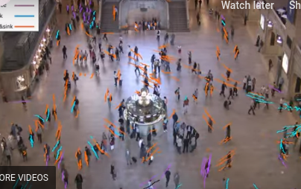
http://mmlab.ie.cuhk.edu.hk/projects/randomfield/

http://www.ee.cuhk.edu.hk/~xgwang/grandcentral.html
http://ped.fz-juelich.de/db/
https://www.researchgate.net/figure/A-screenshot-of-the-the-video-analysed-by-using-the-Tracker-Video-Analysis-and-Modelling_fig3_305477761
https://www.researchgate.net/publication/316715263_Towards_Microscopic_Calibration_of_Pedestrian_Simulation_Models_using_Open_Trajectory_Data-Sets_the_Case_Study_of_the_Edinburgh_Informatics_Forum
http://ped.fz-juelich.de/db/doku.php?id=extdb
https://data.4tu.nl/repository/uuid:25289586-4fda-4931-8904-d63efe4aa0b8
https://github.com/crowdflowTUe/MF_landing_data_analysis
https://journals.aps.org/pre/abstract/10.1103/PhysRevE.95.032316
https://data.4tu.nl/repository/uuid:25289586-4fda-4931-8904-d63efe4aa0b8
https://ieeexplore.ieee.org/document/7881703
http://motion.cs.umn.edu/PowerLaw/
http://cvrr.ucsd.edu/bmorris/datasets/dataset_trajectory_analysis.html

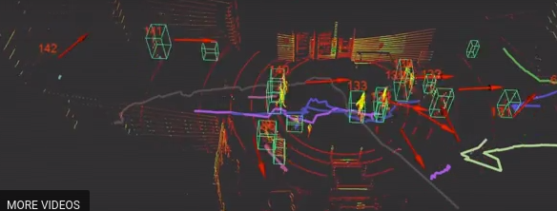
https://lcas.lincoln.ac.uk/wp/3dof-pedestrian-trajectory-dataset/
(coffee shop, cafeteria...)

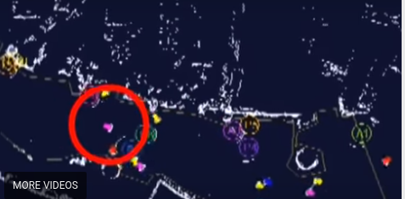
http://www.irc.atr.jp/crest2010_HRI/ATC_dataset/
(japanese shopping mall)

http://web.stanford.edu/~alahi/

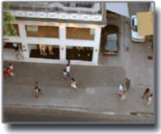
https://onlinelibrary.wiley.com/doi/full/10.1111/j.1467-8659.2007.01089.x
Paper : Crowds by Example

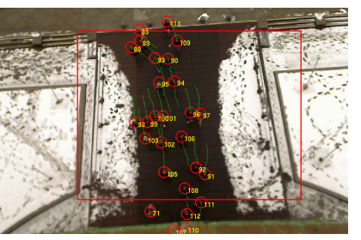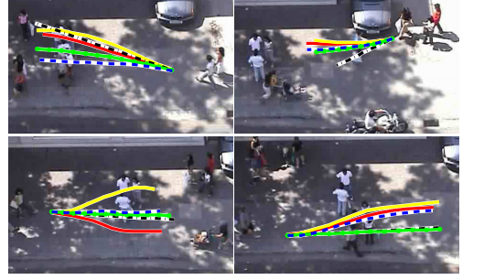
https://ieeexplore.ieee.org/stamp/stamp.jsp?tp=&arnumber=5459260
Paper : You’ll Never Walk Alone: Modeling Social Behavior for Multi-target Tracking

